Early Larval Pacific Oysters Tolerate Moderate, but not Extreme, Ocean Acidification

Ocean acidification impacts size and calcification in Pacific oyster larvae early development

Exposure to ocean acidification levels similar to modern upwelling events and projected future scenarios adversely affect Pacific oyster larvae

Emma Timmins-Schiffman, Michael O’Donnell, Carolyn Friedman, and Steven Roberts

ABSTRACT
Ocean acidification is one of the many environmental changes that are occurring due to anthropogenic consumption of natural resources. As carbon dioxide (CO₂) builds up in the atmosphere, it reaches equilibrium with the surface seawater and its dissolution results in a greater concentration of hydrogen ions, or acidification. Ocean acidification is both a contemporary and a future problem, as upwelled waters along the coast are frequently high in pCO₂/low in pH and atmospheric pCO₂ is expected to increase for the foreseeable future. We raised Pacific oyster, Crassostrea gigas, larvae from fertilization through three days post-fertilization at three different pCO₂: Ambient (400 µatm), MidCO₂ (700 µatm), and HighCO₂ (1000 µatm). Larval size, calcification and developmental stage were recorded throughout the experiment. The larvae raised at the HighCO₂ treatment were smaller and less calcified than those raised at Ambient and MidCO₂. There was no developmental delay observed in any of the treatments.

INTRODUCTION
Ocean acidification is expected to affect all ecosystems at an accelerating pace over the next century (IPCC 2007; Caldeira and Wickett 2003). Ocean acidification occurs due to the reduction of seawater pH in association with the uptake of anthropogenic CO₂ and resultant increased H⁺ ion concentration. Many of the projected changes will have significant consequences for natural populations ranging from molecular physiological changes to broad-scale range shifts (Talmage and Gobler 2011; O’Donnell et al. 2009; Wong et al. 2011; Tomanek et al. 2011; Banks et al. 2010; Perry et al. 2005). The increase in H⁺ ion concentration in seawater is the direct cause for decreased pH (acidification); however, other changes resulting from this same chemical reaction may also have significant effects on aquatic organisms. Increased CO₂ concentration in seawater reduces the gradient between an organism’s internal fluids and its environment thereby hindering release of CO₂ from an organism’s circulatory fluids (Fabry et al. 2008). Increases in internal CO₂ concentrations (hypercapnia) can result in acidosis of metabolic fluids, as seen in the cuttlefish Sepia officinalis (Gutowska et al. 2010), the sea urchin Psammechinus miliaris (Miles et al. 2007), and the mussel Mytilus galloprovincialis (Michaelidis et al. 2005).
When faced with ocean acidification, calcifying aquatic invertebrates must combat both hypercapnia and the added challenge of shell formation and maintenance in a corrosive environment. The dissolution of CO₂ in seawater not only produces more H⁺, it also produces greater concentrations of bicarbonate (HCO₃⁻) and makes the carbonate ion (CO₃²⁻) less available. The latter effect is of great importance to calcifying organisms since they rely on the availability of CO₃²⁻ to form and maintain carbonate-based structures (Beniash et al. 2010; Thomsen and Melzner 2010). Many aquatic invertebrates dissolve their calcified structures to make HCO₃⁻ more available as a buffer against internal acidosis caused by ocean acidification. This phenomenon has been observed across a range of shell-forming invertebrate species: the oyster Crassostrea gigas (Lannig et al. 2010), the limpet Patella vulgata (Marchant et al. 2010), and the urchin Psammechinus miliaris (Miles et al. 2007).
Stresses induced by ocean acidification can have secondary effects on organismal growth, physiology, behavior, and life history. Typically, invertebrate larvae that are reared at higher pCO₂ (partial pressure of CO₂) are smaller and have more developmental abnormalities than those at ambient pCO₂ (Chan et al. 2011; Parker et al. 2010). A host of physiological changes are also associated with changes in pCO₂. Invertebrate larvae raised at elevated pCO₂ show an inhibited ability to launch a heat shock response (O’Donnell et al. 2009) and alterations in both transcriptomic and proteomic profiles (Todgham and Hofmann 2009; Wong et al. 2011; Stumpp et al. 2011b). Urchin larvae (Strongylocentrotus purpuratus) reacted to ocean acidification through changes in expression of genes involved in acid-base balance, ion regulation, biomineralization and skeletogenesis, cellular stress response, metabolism, and apoptosis (Todgham and Hofmann 2009; Stumpp et al. 2011b). In larval barnacles (Balanus amphitrite), Wong et al. (2011) detected changes in expression of proteins involved in respiration, energy metabolism, endocytosis, cell matrix degradation, and cellular stress. These physiological changes suggest that ocean acidification has negative and potentially long-lasting effects on invertebrate species.
Sustained environmental change, such as ocean acidification, can negatively affect both the ecosystem and economy. Oysters provide important ecosystem services such as improved water quality and benthic-pelagic coupling through the filtration of large volumes of water and release of feces and pseudofeces to the benthos on a daily basis, and create habitat via reef formation for a myriad of other estuarine organisms (Coen and Luckenbach 2000). In addition to their ecological roles, molluscs are economically important to many coastal communities worldwide. In 2008, molluscs comprised 64.1% (or 13.1 million tons) of total aquaculture production, with oysters accounting for 31.8% of the total production (FAO 2010). Recently, in the Pacific Northwest of the U.S., concern has heightened over the already apparent effects of corrosive, acidified water on both natural and hatchery production of C. gigas larvae (Elston et al. 2008, Feely et al. 2010).
This study characterized the effects of two elevated levels of pCO₂ on size, calcification and development during early larval stages of the Pacific oyster, Crassostrea gigas. Oyster larvae were raised in two elevated levels of pCO₂ (700 and 1000 µatm) and ambient (400 µatm) seawater from fertilization through three days post-fertilization.

METHODS
Seawater chemistry manipulation
Experimental conditions were maintained using a flow-through seawater system in Friday Harbor, Washington, USA. Water entering the system was filtered (0.2 µm), UV sterilized, and CO₂-depleted using membrane contactors (Membrana, Charlotte, NC, USA) under partial vacuum. Three experimental treatments were chosen to correspond with dissolved CO₂ levels of 400, 700 or 1000 ppm in the atmosphere. These levels correspond to near current ambient oceanic conditions, projection for mid-century pCO_{2,} and end-of-century pCO₂, respectively (IPCC 2007). These CO₂ levels also reflect those currently observed in near and inshore marine waters of the northeastern Pacific (Feely et al. 2008). These three treatments will be referred to throughout the manuscript as Ambient, MidCO₂, and HighCO₂. Set-point pH levels were determined with the program CO₂SYS (Robbins et al. 2010) using an average alkalinity of 2060 µmol kg⁻¹ based on total alkalinity measurements taken the week prior to the experimental trial.
Larval C. gigas were held 3 L microcosms within a large reservoir filled with the respective treatment water. Ambient air stripped of CO₂ by a CO₂ adsorbtion unit (Twin Tower Engineering, Broomfield, CO, USA) was used to aerate the seawater within the reservoirs. This replaced oxygen lost through the degassing process. Reservoir pH was continuously monitored by a Durafet III pH probe (Honeywell, Morristown, NJ, USA) and pure CO₂ (Praxair, Danbury, CT, USA) was added to each system by a Honeywell UDA2182 pH controller in order to maintain pH in the three systems.
Seawater was pumped from the reservoir into larval microcosms through irrigation drippers (DIG Industries, Sun Valley, CA, USA) at a rate of 1.9 L per hour. An outflow tube at the top of the microcosms fitted with 35 µm mesh allowed water to exit the microcosms while retaining larvae. All systems were equilibrated to the correct treatment level 48 hours prior to the start of the experiment. Water temperature was held at 20.4°C ± 0.4°C

Oysters
Ten female and four male adult C. gigas were collected from Argyle Creek in Friday Harbor, WA in July 2011. Oysters were strip-spawned with eggs and sperm pooled separately (day zero). Pooled eggs (approximately 2 million) were divided equally into 18 7.5cm diameter containers. Sperm was diluted in Ambient seawater and added to each container of eggs. After the addition of sperm, the eggs were gently agitated and incubated for 15 minutes to allow for fertilization.
Six containers of fertilized eggs were transferred to microcosms containing one of three treatment conditions. Initial densities post-hatching were approximately 1 larva mL⁻¹. On days 1 and 3 post-fertilization, larvae were randomly sampled to determine survival, size, developmental stage, and degree of calcification. For each microcosm sampled, larvae were filtered onto 35 µm mesh screens and washed. Approximately 100 larvae were removed from each tube. Larvae were relaxed with 7.5% MgCl₂ and fixed in 4% paraformaldehyde buffered in filtered seawater. The remaining larvae were returned to cleaned microcosms filled with new seawater. Larvae were fed Dunaliellia sp. and Isochrysis sp. at concentrations of 30,000 cells mL⁻¹ each on day two. During feeding, water flow was turned off in microcosms for two hours. All microcosms were cleaned at each sampling event.
Larvae were examined using light microscopy to determine size, developmental stage and degree of calcification. Larval hinge length and shell height were measured at 10x magnification with a Nikon Eclipse E600 and NIS Elements Basic Research software (Nikon, Tokyo, Japan). Larval developmental stage and calcification were determined at 20x magnification using an inverted microscope and double polarized light for calcification. Larvae were scored as calcified on day one post-fertilization if calcification was observed at the hinge. On day 3 post-fertilization, larvae were classified as fully calcified if polarized light produced a “maltese cross” in the larval shell (Figure 1; LaBarbera 1974).

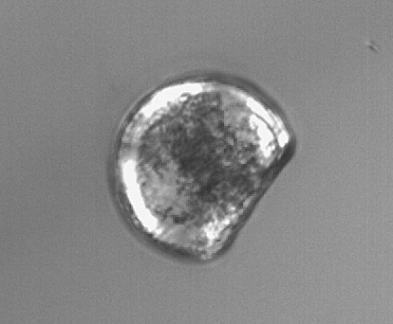
Figure 1. Fully calcified D-hinge C. gigas larva revealing a Maltese cross under polarized light.

Carbonate chemistry
Throughout the experiment salinity was measured with a conductivity meter (Hach sensION5; Loveland, CO, USA) and temperature was measured using a Fluke 1523 thermometer (Fluke, Everett, WA, USA). Seawater pH entering the microcosms was measured daily using the spectrophotometric (spec) technique outlined in SOP 6b by Dickson et al. (2007) to confirm pH measurements from the Durafet probe. When any discrepancies were observed, the Durafet probe was recalibrated. Seawater pH measurements were taken from two microcosms per treatment on days 0, 1, and 3. Final pH values reported here have been corrected for dye addition and temperature. Total alkalinity (A_{T}) was measured following the open cell titration of SOP 3b (Dickson et al. 2007). Samples for A_{T} were taken from incoming water and from two microcosms in each treatment on days 0, 2, and 3. CO₂SYS (Robbins et al. 2010) was used to calculate calcium carbonate saturation state (Ω) of aragonite and calcite and pCO₂ with A_{T} and pH as inputs using the following constants: Lueker et al. (2000) for CO₂ Constants, Dickson (1990b) for KHSO₄, Total scale (mol kg⁻¹ SW) for pH scale, and Wanninkhof (1992) for Air-Sea Flux.

Statistics
Differences in larval size among treatment were examined using a two-way ANOVA with fixed effects of treatment and day followed by Tukey’s Honestly Significant Difference test (Tukey’s HSD). A one-way ANOVA was also used to test for differences in larval size among treatments using the combined fixed factor of day-treatment. Larval calcification and developmental stage were compared among treatments using a generalized linear model (GLM). Binomial error distributions were used for GLM analyses. All analyses were performed in R (R Development Core Team 2011).

RESULTS
Carbonate chemistry
Throughout the experiment seawater pH differed across treatments and A_{T} varied with natural fluctuations in the local water (Table 1). Mean seawater pH was consistent within but varied among treatments (Figure 2). Mean pH, as measured by the Durafet pH probes (Figure 2) was 7.99 in the Ambient treatment, 7.75 in the MidCO₂ treatment and 7.66 in the HighCO₂ treatment. Aragonite and calcite saturation states were greater than 1.0 for the duration of the experiment, except in the HighCO₂ treatment on days 1 and 2 (Table 1). Partial pressure of CO₂ in the seawater averaged 468 µatm in the Ambient treatment, 847 µatm in the MidCO₂ treatment, and 1065 µatm in the HighCO₂ treatment.

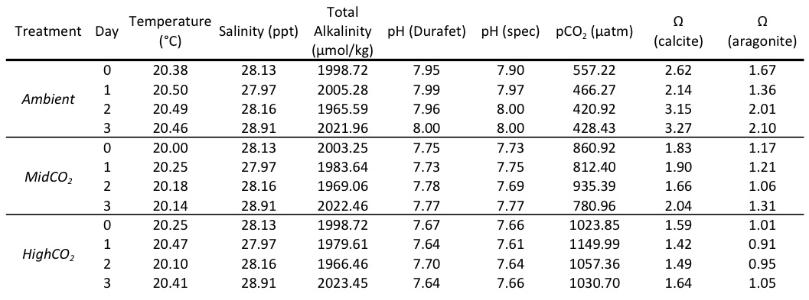
Table 1. Water chemistry data for three experimental treatments – Ambient, MidCO₂, and HighCO₂. Temperature and Durafet pH measurements are averages from each day based on the Honeywell controller logs. Salinity, total alkalinity (A_{T}), and spectrophotometric (spec) pH are point measurements taken each day. Partial pressure of CO₂ and Ω were calculated from spec pH and A_{T}.
Figure 2. Profiles of pH measurements in the three different treatments – Ambient (black), MidCO₂ (light gray), and HighCO₂ (dark gray). Average pH for the experiment for each treatment is represented by solid lines. The Durafet probes recorded pH measurements every minute.

Size, development, and calcification
Larval size (shell height and hinge length) was similar across experimental treatments after 24 hours, however by day 3 larvae grew significantly larger (height and length) in the Ambient and MidCO₂ compared to the HighCO₂ treatment (Table 2). Between days 1 and 3 larvae increased in size under Ambient conditions (shell height) and MidCO₂ conditions (shell height and hinge length; Table 2).
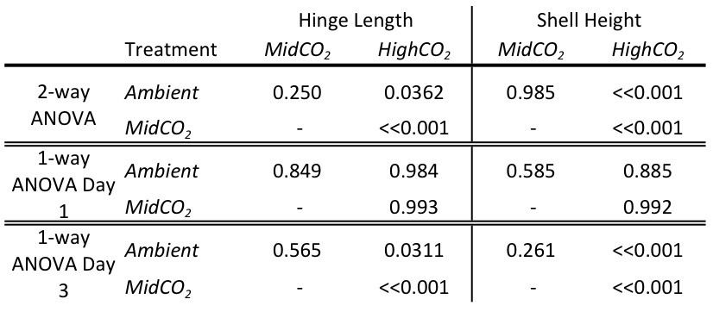
Table 3. Results from post-hoc Tukey’s HSD following ANOVA for comparisons of hinge length and shell height. The 2-way ANOVA was performed with “treatment” and “day” as fixed effects and the one-way ANOVA was performed with the fixed effect of “day-treatment”.

Developmental rate did not vary across treatments. On day 1, a slightly greater proportion (0.977) of larvae at HighCO₂ were at the D-hinge stage (compared to those that were still trocophores), but this difference was not significant (z-value=1.016, p=0.310; data not shown). The proportion of larvae at the D-hinge stage in the Ambient treatment was 0.875 and in MidCO₂ was 0.833. By day 3, all larvae observed across treatments were at the D-hinge stage (z-value=1.55e-4, p=1).
Larval calcification was significantly different between treatments for days 1 and 23post-fertilization. Following 24 hours of treatment (day 1) calcification was greater in the HighCO₂ treatment (z-value=2.084, p=0.0372, Figure 5). On day 3, larvae at HighCO₂ conditions were less calcified than the other two treatments (z-value=-3.203, p=0.00136).
Survival was near 100% in all the treatments at day 1. On day 3, survival was still near 100% in the Ambient treatment, but was at about 85% in both the MidCO₂ and HighCO₂ treatments.

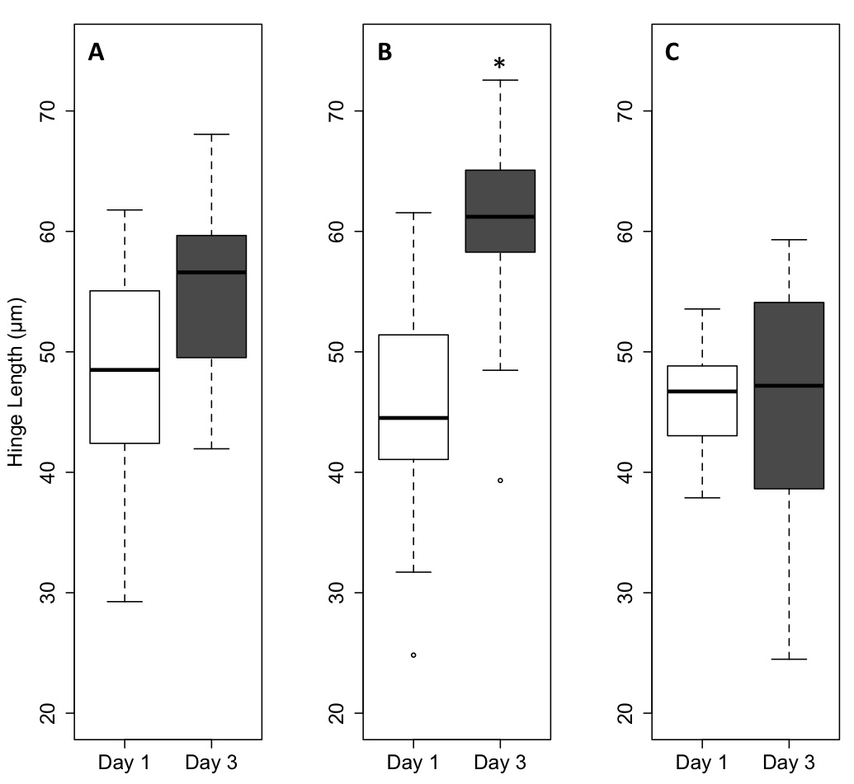
Figure 3. Larval hinge length by and day (boxplots corresponding to day one are white and those for day three are gray). Data from the Ambient treatment are in panel A, MidCO₂ are in panel B, and HighCO₂ are in panel C. The boxplots contain the middle 50% of the data and the bars extending from the plots encompass the data within 1.5 times the spread of the middle 50%. The open circles beyond the bars are outliers. The horizontal black bar in the plots is the median value of each data set. On day 3, larvae in the HighCO₂ treatment are significantly smaller than those in the other two treatments (p < 0.05). Only the larvae raised in the MidCO₂ treatment were significantly larger on day 3 compared to day 1 (p < 0.01).
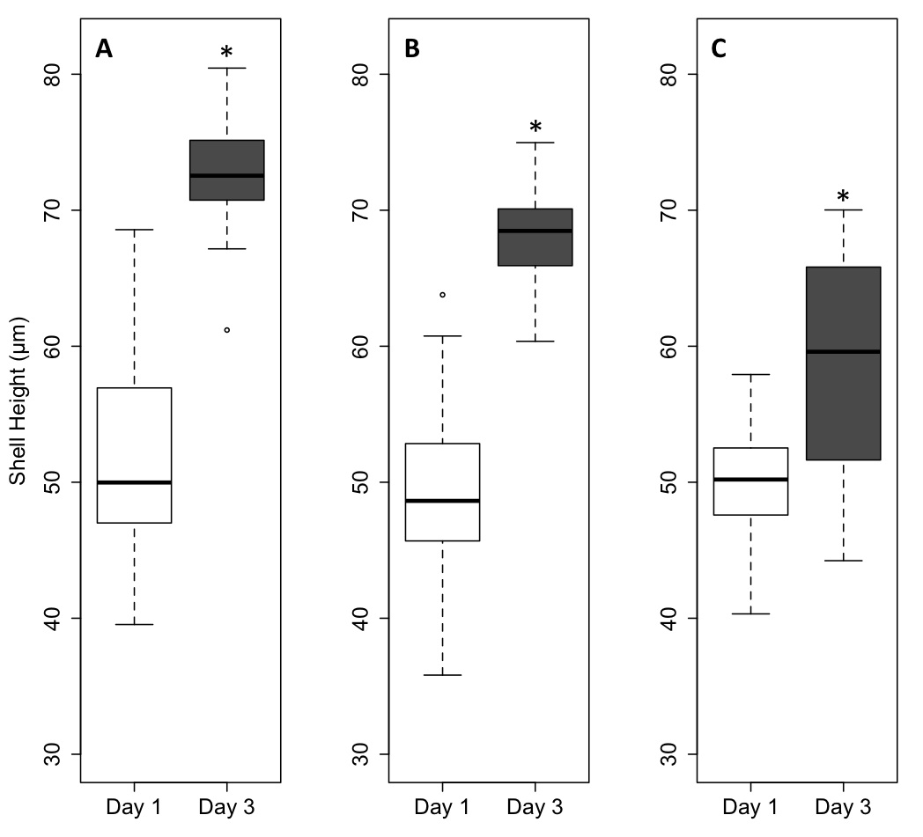

Figure 4. Larval shell height by treatment and day (boxplots corresponding to day one are white and those for day three are gray). Data from the Ambient treatment are in panel A, MidCO₂ are in panel B, and HighCO₂ are in panel C. The boxplots contain the middle 50% of the data and the bars extending from the plots encompass the data within 1.5 times the spread of the middle 50%. The open circles beyond the bars are outliers. The horizontal black bar in the plots is the median value of each data set. On day three, larvae at HighCO₂ had shorter shell height than the larvae raised at Ambient and at MidCO₂ (p < 0.01). Shell height in all three treatments increased significantly from day 1 to 3 (p < 0.01).
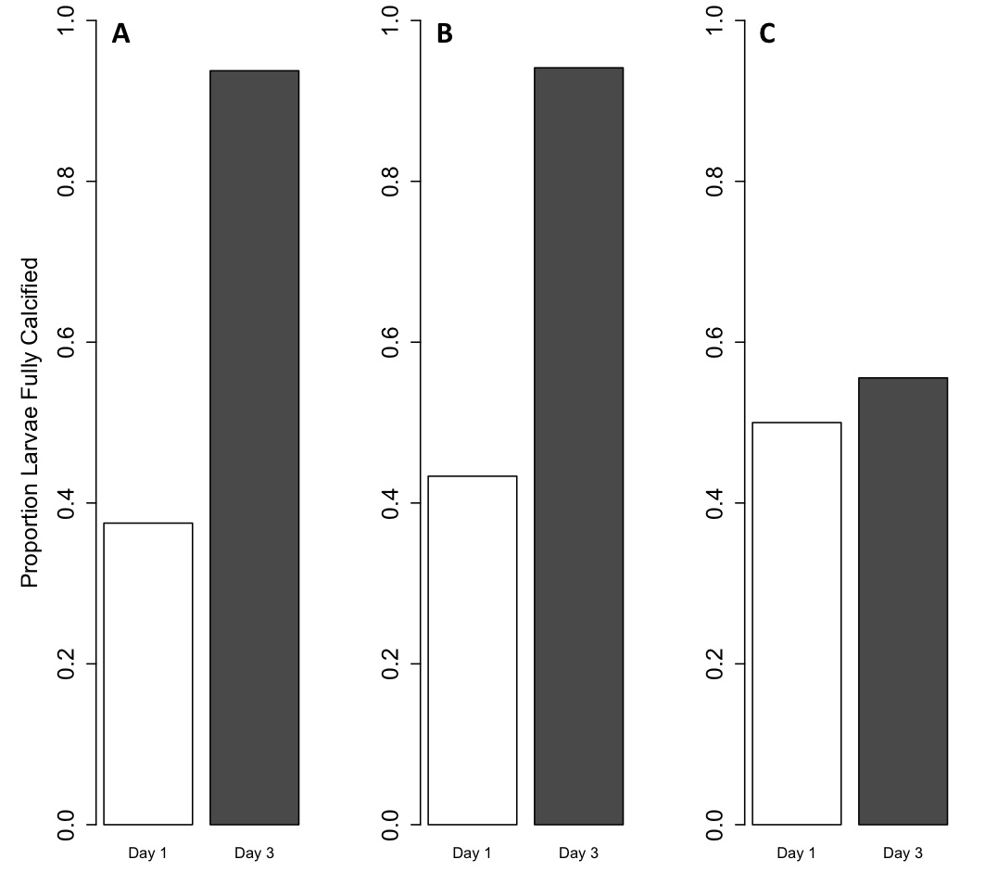
Figure 5. Proportion of larvae calcified exposed to elevated pCO₂. Bars represent calcification on day 1 are white; those representing day 3 are gray. Proportion larvae calcified from the Ambient treatment is in panel A, MidCO₂ treatment is panel B, and HighCO₂ treatment is panel C. There is a significant difference in calcification between treatments, with the highest proportion larvae calcified at HighCO₂ on day 1 and the fewest larvae calcified in the same treatment on day 3.

DISCUSSION
In this study we have determined that C. gigas larvae appear to tolerate moderate acidification in early development, but more extreme acidification results in significant reductions in larval size and calcification by day 3 post-fertilization. C. gigas’s physiological plasticity at this developmental stage is exceeded by a pCO₂ between the Mid- and HighCO₂ treatments. The chemistry scenarios simulated in this study are based on projections for the coming century, but these values of low pH and Ω are already occurring with increasing frequency in the nearshore waters off the U.S. West coast (Feely et al. 2010; Hauri et al. 2009), which is habitat to C. gigas and many other bivalve species. The successful development of larvae depends not only on slowing the rate of future acidification, but also on mitigating current acidification of nearshore environments.

Size and calcification were affected by pCO₂
C. gigas larvae raised at HighCO₂ were smaller and less calcified by day 3 post-fertilization, but did not show a developmental delay. Maternal effects may have been responsible for sustained development under environmental stress. A congener of C. gigas, C. viriginica, maintained maternally derived lipid reserves up through four days post-fertilization (Gallager et al. 1986). Maternally derived lipids could have provided the energy necessary for development even as shell growth and calcification were inhibited by environmental conditions. If the environmental stress of ocean acidification had continued past this stage where maternal lipids are still available, it is probable that we would have observed signs of an altered energy budget in the oyster larvae. An altered energy budget can lead to decreased size, less calcification, and developmental delay at elevated pCO₂ (Crim et al. 2011; Yu et al. 2011; Kimura et al. 2011; Parker et al. 2010; Dupont et al. 2008; Stumpp et al. 2011a).
In order to survive a sustained environmental stress that requires a significant energy input, organisms may need to shift their energy balance away from homeostatic physiological processes, such as growth, calcification, and development. Since ocean acidification affects calcification and acid-base balance, larval invertebrates seem to invest significant amounts of energy to combat it (e.g., Stumpp et al. 2011a). Changes in ionic concentration due to hypercapnia and calcified structure dissolution can result in overall shifts in cellular ion gradients, which could significantly alter cellular processes (Dissanayake et al. 2010). Overall, changes in environmental and internal organismal carbonate chemistry create a more stressful and energetically demanding environment for aquatic invertebrates.
The aragonite saturation state (Ω_{Ar}) was considerably different in the HighCO₂ treatment and this carbonate chemistry alteration may have played a significant role in the decreased size and calcification of the oysters. A number of studies have similarly found that exposure to elevated pCO₂ leads to decreased size and calcification in invertebrate larvae and that these effects are most likely caused by a decreased Ω_{Ar}. Elevated pCO₂ of 750 ppm had significant negative effects on hard clam (Mercenaria mercenaria) and bay scallop (Argopecten irradians) larvae as evidenced by decreased survival, development, growth and lipid synthesis (Talmage and Gobler 2011). In the Ezo abalone, Haliotis discus hannai, larvae raised in elevated pCO₂ were smaller and showed a greater prevalence of developmental abnormalities (Kimura et al. 2011). Kurihara et al. (2007) observed significantly smaller and more partially and uncalcified veliger larvae at a pH of 7.4. Similarly, C. gigas larval survival and mid-stage growth in the hatchery were impacted by decreased Ω_{Ar} when exposed during spawning (Barton et al. in review). In many of these scenarios, Ω_{Ar} may be the primary culprit, as opposed to elevated pCO₂. C. gigas larvae exposed to different ocean acidification scenarios after fertilization demonstrated decreased viability, size and calcification only when Ω_{Ar} was low, irrespective of pCO₂ level (Gazeau et al. 2011). Even short-term exposure to decreased Ω_{Ar} during vulnerable developmental periods can adversely affect later larval stages (Barton et al. in review).
Maintaining a smaller size in a stressful environment may provide an energetic advantage as less energy allocated towards growth leaves more energy available to counteract the stress. However, the smaller size of larvae at higher pCO₂ could lead to disadvantages. Smaller veliger larvae are not able to feed as efficiently as larger ones (Strathmann and Leise 1979). Larval sand dollars, Dendraster excentricus, responded to increased pCO₂ through changes in morphology that resembled a starvation response without the usual compensation of longer arms that allow for greater food capture (Chan et al. 2011). Exposure to ocean acidification altered the larval sand dollar ciliary beat pattern, thus decreasing the efficiency of particle capture, leading to decreased stomach size (Chan et al. 2011). C. gigas larvae also depend on ciliary movement for feeding, although the direct effects of ocean acidification on this mechanism are unknown. It is impossible to determine from this study if decreased ability to acquire food or less available energy for growth is the main cause for stunted larval size, but these combined impacts of ocean acidification could have additive or multiplicative effects on larval growth.
The effects of ocean acidification on invertebrate larvae that are observed in controlled experiments tend to have some commonalities, but also can vary considerably between experiments. These differences are in large part due to the number of parents used to produce the offspring and the ecological and evolutionary histories of the source populations. The use of only a few parents in some studies biases the results since the group of larvae will have a limited range of phenotypes. In a population of a broadcast spawning species, each generation will have a broad range of phenotypes correlated to the diversity of genotypes. In the laboratory, pooling gametes from multiple adults simulates a more accurate “spawning” event (Byrne in press). Different selection regimes can also impact how a population will respond to ocean acidification. Selectively bred Syndney rock oyster larvae, Saccostrea glomerata, were less affected by elevated pCO₂ than larvae spawned from a wild population (Parker et al. 2010). Due to these differences in methods and in source of parents, it is difficult to compare results across studies beyond basic qualitative themes.

Timing of the effects of ocean acidification
Larvae raised at HighCO₂ had the greatest percent calcification at 1 day post-fertilization, but then the trend reversed and they showed the least amount of calcification on day 3. This pattern could be due to the energetic demands of an environmental stress or varying effects of ocean acidification at different larval stages. The larvae could be attempting to protect themselves against a hostile environment by increasing production of CaCO₃. If the acidification event had been transient, as they frequently are in nearshore upwelling systems, more calcification at an early stage may have ensured that the larvae would have some shell left once the acidified water passed. When the environmental stress proved to be permanent, the larvae could no longer maintain the excess energy investment and their growth and calcification fell behind those of the larvae raised at lower pCO₂ levels.
The effects of ocean acidification may vary depending on larval stage as well as have an increasing effect on larvae over a long-term exposure. Urchin larvae, Strongylocentrotus purpuratus, at elevated pCO₂ were smaller than controls throughout development, but this difference was greater at later stages (Stumpp et al. 2011a). Routine metabolic rate in these same larvae was not affected by treatment until after feeding began at 5 days post-fertilization (Stumpp et al. 2011a). C. gigas larvae were not affected by elevated pCO₂ in very early development until the D-hinge and veliger stages when greater abnormalities and smaller size were observed (Kurihara et al. 2007). The way in which larvae experience an environmental stress likely depends on their ecological and biological needs at that specific time point in development. Since ocean acidification currently occurs as a more transient stress brought on by upwelled waters, larvae that encounter the acidified water at a less vulnerable stage may not be adversely impacted. However, as acidified waters become more prevalent and persistent, the chance of larvae encountering ocean acidification will increase, as will the chance for negative developmental effects.

Conclusions
The potential for local adaptation during climate change may prove to be the key to population persistence of C. gigas and similar species. As broadcast spawners, individual C. gigas can produce thousands of larvae with each reproductive effort. Within a population, the proportion of larvae that survive is determined in part by chance (sweepstakes selection; Hedgecock 2007) and in part by having the genotype that is fit in the contemporary environment. Thus, broadcast spawners have the life history potential to both acclimatize and adapt to environmental change. If planktonic larvae have a long enough larval period so that the spatial scale of gene flow is greater than the scale of the selective gradient, then post-settlement purifying selection within each generation can maintain overall population genetic diversity (Sanford and Kelly 2011; Somero 2010). Maintenance of this diversity could provide the genetic resources necessary for future adaptive responses during climate change. Genetic diversity could be maintained as long as wild populations are not exposed to a strong selection pressure that encompasses a similar range as their gene flow. The selection pressure could take the form of a single significant event or could be caused by co-occurring multiple stressors.
Ocean acidification is a current and future challenge and will continue to negatively impact aquatic organisms. These impacts are of both ecological and economic concern since the effects of ocean acidification are seen across taxonomic groups (i.e. on an ecosystem-level scale) and have the potential to decrease the viability of commercially important populations. This research contributes to the growing evidence than ocean acidification has the ability to reduce the viability of marine invertebrate larvae. However, given the wide range of genotypes that arise from broadcast spawning events in every generation, there is the possibility for acclimatization and adaptation over time for C. gigas and similar species. Further studies that investigate genotype-dependent survival under future climate change scenarios will help to determine if ocean acidification and associated climate shifts will prove to be surmountable selective pressures or harbingers of local extinction events.

LITERATURE CITED

Banks, S.C., Ling, S.D., Johnson, C.R., Piggott, M.P., Williamson, J.E., Behergegaray, L.B., 2010. Genetic structure of a recent climate change-driven range extension. Molecular Ecology. 19: 2011-2024.
Barton, A., Hales, B., Waldbusser, G., Langdon, C., Feely, R.A., in review. The Pacific oyster, Crassostrea gigas, shows a negative correlation to naturally elevated carbon dioxide levels: Implications for near-term ocean acidification impacts. Limnology and Oceanography.
Beniash, E., Ivanina, A., Lieb, N.S., Kurochkin, Il, Sokolova, I.M., 2010. Elevated levels of carbon dioxide affects metabolism and shell formation in oysters Crassostrea virginica. Marine Ecology Progress Series, 419: 95-108.
Byrne, M., in press. Global change ecotoxicology: Identification of early life history bottlenecks in marine invertebrates, variable species responses and variable experimental approaches. Marine Environmental Research, doi:10.1016/m.marenvres.2011.10.004
Caldeira, K., Wickett, M.E., 2003. Anthropogenic carbon and ocean pH. Nature. 365.
Chan, K.Y.K., Grünbaum, D., O’Donnell, M.J., 2011. Effects of ocean-acidification-induced morphological changes on larval swimming and feeding. J. Exp. Biol., 214: 3857-3867.
Coen, L.D., Luckenbach, M.W., 2000. Developing success criteria and goals for evaluating oyster reef restoration: Ecological function or resource exploitation? Ecological Engineering, 15: 323-343.
Crim, R.N., Sunday, J.M., Harley, C.D.G., 2011. Elevated seawater CO2 concentrations impair larval development and reduce larval survival in endangered northern abalone (Haliotis kamtschatkana). Journal of Experimental Marine Biology and Ecology, 400: 272-277.
Dissanayake, A., Clough, R., Spicer, J.I., Jones, M.B., 2010. Effects of hypercapnia on acid-base balance and osmo-/iono-regulation in prawns (Decapoda: Palaemonidae). Aquat. Biol. 11: 27-36.
Dupont, S., Havenhand, J., Thorndyke, W., Peck, L., Thorndyke, M., 2008. Near-future level of CO₂-driven ocean acidification radically affects larval survival and development in the brittlestar Ophiothrix fragilis. Mar. Ecol. Prog. Ser., 373: 285-294.
Elston, R.A., Hasegawa, H., Humphrey, K.L., Polyak, I.K., Häse, C.C., 2008. Re-emergence of Vibrio tubiashii in bivalve aquaculture: severity, environmental drivers, geographic extent, and management. Dis. Aquat. Org., 82: 119-134.
Fabry, V.J., Seibel, B.A., Feely, R.A., Orr, J.C., 2008. Impacts of ocean acidification on marine fauna and ecosystem processes. ICES J. Mar. Sci. 65: 414-432.
FAO Fisheries and Aquaculture Department, 2010. World aquaculture 2010. FAO Fisheries and Aquaculture Department. Technical Paper. No. 500/1. Rome, FAO. 2011. 105 pp.
Feely, R.A., Sabine, C.L., Hernandez-Ayon, J.M., Ianson, D., Hales, B., 2008. Evidence for upwelling of corrosive “acidified” water onto the continental shelf. Science, 320: 1490-1492.
Feely, R.A., Alin, S.R., Newton, J., Sabine, C.L., Warner, M., Devol, A., Krembs, C., Maloy C., 2010. The combined effects of ocean acidification, mixing, and respiration on pH and carbonate saturation in an urbanized estuary. Estuaring, Coastal and Shelf Science, 88: 442-449.
Gallager, S.M., Mann, R., Sasaki, G.C., 1986. Lipid as an index of growth and viability in three species of bivalve larvae. Aquaculture, 56: 81-103.
Gazeau, F., Gattuso, J.-P., Greaves, M., Elderfield, H., Peene, J., Heip, C.H.R., Middelburg, J.J., 2011. Effects of carbonate chemistry alteration on early embryonic development of the Pacific oyster (Crassostrea gigas). PLoS One. 6: E23010. Doi:10.1371/journal.pone.0023010
Gutowska, M.A., Melzner, F., Langenbuch, M., Bock, C., Claireaux, G., Pörtner, H.O., 2010. Acid-base regulatory ability of the cephalopod (Sepia officinalis) in response to environmental hypercapnia. J. Comp. Physiol. B., 180: 323-335.
Hauri, C., Gruber, N., Plattner, G.-K., Alin, S., Feely, R.A., Hales, B., Wheeler, P.A., 2009. Ocean acidification in the California Current System. Oceanography, 22: 60-71.
Intergovernmental Panel on Climate Change (IPCC), 2007. Contribution of Working Groups I, II, and III to the Fourth Assessment Report of the Intergovernmental Panel on Climate Change. Pachauri, R.K., Reisinger, A. (Eds.), IPCC, Geneva, Switzerland, pp. 104.
Kimura, R., Takami, H., Ono, T., Onitsuka, T., Yukihiro, N., 2011. Effects of elevated pCO2 on the early development of the commercially important gastropos, Ezo abalone Haliotis discus hannai. Fisheries Oceanography. 20: 37-366.
Kurihara, H., Kato, S., Ishimatsu, A., Effects of increased seawater pCO2 on early development of the oysters Crassostrea gigas. Aquatic Biology, 1: 91-98.
LaBarbera, M., 1974. Calcification of the first larval shell of Tridacna squamosa (Tridacnidae: Bivalvia). Marine Biology, 25: 233-238.
Lannig, G., Eilers, S., Pörtner, H.O., Sokolova, I.M., Bock, C., 2010. Impact of ocean acidification on energy metabolism of Oyster, Crassostrea gigas-Changes in metabolic pathways and thermal response. Mar. Drugs, 8: 2318-2339.
Marchant, H.K., Calosi, P., Spicer, J.I., 2010. Short-term exposure to hypercapnia does not compromise feeding, acid-base balance or respiration of Patella vulgata but surprisingly is accompanied by radula damage. Journal of the Marine Biological Association of the United Kingdom, 90: 1379-1384.
Michaelidis, B., Ouzounis, C., Paleras, A., Pörtner, H.O., 2005. Effects of long-term moderate hypercapnia on acid-base balance and growth rate in marine mussels Mytilus galloprovincialis. Marine Ecology Progress Series, 293: 109-118.
Miles, H., Widdicombe, S., Spicer, J.I., Hall-Spencer, J., 2007. Effects of anthropogenic seawater acidification on acid-base balance in the sea urchin Psammechinus miliaris. Marine Pollution Bulletin, 54: 89-96.
O’Donnell, M.J., Hammond, L.M., Hofmann, G.E., 2009. Predicted impact of ocean acidification on a marine invertebrate: elevated CO₂ alters response to thermal stress in sea urchin larvae. Marine Biology. 156: 439-446.
Parker, L.M., Ross, P.M., O’Connor, W.A., 2011. Populations of Sydney rock oyster, Saccostrea glomerata, vary in response to ocean acidification. Marine Biology, 158: 689-697.
Perry, A.L., P.J. Low, J.R. Ellis and J.D. Reynolds. 2005. Climate change and distribution shifts in marine fishes. Science. 308:1912-1915.
Robbins, L.L., Hansen, M.E., Kleypas, J.A., and Meylan, S.C., 2010, CO2calc: A User-Friendly Carbon Calculator for Windows, Mac OS X, and iOS (iPhone): U.S. Geological Survey Open File Report 2010-1280, 42pp.
Sanford, E., Kelly, M.W., 2011. Local adaptation in marine invertebrates. Annual Review of Marine Science, 3: 509-535.
Somero, G. N., 2010. The physiology of climate change: how potentials for acclimatization and genetic adaptation will determine ‘winners’ and ‘losers’. J. Exp. Biol. 213: 912-920.
Strathmann, R.R., Leise, E., 1979. On feeding mechanisms and clearance rates of molluscan veligers. Biol. Bull., 157: 524-535.
Stumpp, M., Wren, J., Melzner, F., Thorndyke, M.C., Dupont, S.T., 2011a. CO₂ induced seawater acidification impacts sea urchin larval development I: Elevated metabolic rates decrease scope for growth and induce developmental delay. Comparative Biochemistry and Physiology – Part A: Molecular & Integrative Physiology, 160: 331-340.
Stumpp, M., Dupont, S., Thorndyke, M.C., Melzner, F., 2011b. CO₂ induced seawater acidification impacts sea urchin larval development II: Gene expression patterns in pluteus larvae. Comparative Biochemistry and Physiology – Part A: Molecular & Integrative Physiology, 160: 320-330.

Talmage, S.C., Gobler, C.J., 2011. Effects of elevated temperature and carbon dioxide on the growth and survival of larvae and juveniles of three species of northwest Atlantic bivalves. PLoS One. 6: e26941. Doi: 10.1371/journal.pone.0026941.
Thomsen, J., Melzner, F., 2010. Moderate seawater acidification does not elicit long-term metabolic depression in the blue mussel Mytilus edulis. Marine Biology. 157: 2667-2676.
Todgham, A.E., Hofmann, G.E., 2009. Transcriptomic response of sea urchin larvae Strongylocentrotus purpuratus to CO₂-driven seawater acidification. J. Exp. Biol., 212: 2579-2594.
Tomanek, L., Zuzow, M.J., Ivanina, A.V., Beniash, E., Sokolova, I.M., 2011. Proteomic response to elevated P_{CO2} level in eastern oysters, Crassostrea virginica: evidence for oxidative stress. J Exp. Biol., 214: 1836-1844.
Wong, K.K.W., Lane, A.C., Leung, P.T.Y., Thiyagarajan, V., 2011. Response of larval barnacle proteome to CO₂-driven seawater acidification. Comparative Biochemistry and Physiology Part D: Genomics and Proteomics, 6: 310-321.
Yu, P.C., Matson, P.G., Martz, T.R., Hofmann, G.E., 2011. The ocean acidification seascape and its relationship to the performance of calcifying marine invertebrates: Laboratory experiments on the development of urchin larvae framed by environmentally-relevant pCO₂/pH. Journal of Experimental Marine Biology and Ecology, 400: 288-295.
Zhao, S., Fernald, R.D., 2005. Comprehensive algorithm for quantitative real-time polymerase chain reaction. J. Comput. Biol., 12: 1045-1062.

